Alcohol and Drugs Needs Assessment v0.3
  - Lancashire

  - November 2022

Contents
Executive summary 2
Introduction 4
The National Drug Strategy 2021 4
Needs assessment and action plan 5
Breaking the supply chain 6
Alcohol-related crime 6
Drug offences 7
Reoffending rates 8
Organised crime 9
County Lines 9
Treatment and Recovery 10
Impact of COVID-19 on drug treatment 10
Drug-related deaths 10
Hospital admissions due to drug poisoning 11
Rates of unmet need 12
Measures of recovery 12
People in treatment: by substance, sex, and age 14
Adults in treatment 14
Young people in treatment 15
Early unplanned exits 15
Deaths in treatment 16
Co-occurring mental health and substance misuse conditions 16
Tobacco 17
Clients in contact with the criminal justice system 17
Prevention 19
Types of prevention interventions 19
Prevention interventions in Lancashire 19
Support and signposting 23
Acknowledgements 24
Appendix 25

Executive summary

Breaking the supply chains

- In the five-year period from 2017 to 2022 there has been a reduction of 17% in the number of recorded alcohol-related crimes. As a proportion of all crime, alcohol-related crime has reduced from 14.4% to 11% during this period.
- All recorded drug offences have seen an increasing trend over the last five years, with a 36% increase when comparing 2017/18 to 2021/22. Three of the five areas with the largest volumes and highest rates per 1000 population are within the east of the county – Burnley, Hyndburn and Pendle.
- Outcomes rates for all drug offences – positive outcomes for 2022 are at their highest since 2017 – currently 73%.
- The latest reoffending rate for Lancashire is 22.6%. The rates have been reducing over the last ten years, and have previously been as high as 35%. The number of reoffences per reoffender has remained quite static throughout the ten year period.
- When looking at index offences and in particular theft – as this is often linked to those most in need – the reoffending rate for these offenders is higher than any other crime offence category. For the last ten years this rate has been consistently around 50%.
- The threat from serious organised crime is often hidden and/or unreported. The most direct harm continues to be through the distribution and supply of controlled drugs. The latest information shows that areas across Lancashire are being impacted upon county lines originating from Merseyside, Manchester and West Yorkshire.

Treatment and recovery

- Based on 2016/17 estimates Lancashire has a similar prevalence of opiate and/or crack users (OCUs) compared to England (9.1 versus 8.9 per 1,000 of the population aged 15-64, respectively). This is significantly lower compared to Blackburn with Darwen (18.8) and Blackpool (23.5).
- A total of 6119 adults in Lancashire were in drug and alcohol treatment for the year ending March 2022, which is a 1.1% increase compared to the same period ending March 2021. Just over 40% of this total were new to treatment in 2022 (similar to England, Blackburn with Darwen, and Blackpool).
- For the year-ending March 2020-21 there were 340 young people in community structured treatment, for under 18s, and 18-24s in young people’s services.
- Approximately half of opiates and/or crack cocaine users (OCUs) are not currently in treatment (48% compared to 53% in England). Lancashire is third out of 16 comparable LAs (range 42.9% (Cumbria) to 65.2% (Essex)). For opiates, 40% of users in Lancashire are not currently in treatment compared to 47% in England, crack users 53% versus 58%, and alcohol users 84% versus 82%. Lancashire data are similar to Blackburn with Darwen and Blackpool.
- 5.7% of opiate users successfully completed drug treatment and did not re-present within six months (similar to England (5.0%), Blackburn with Darwen (6.2%), and Blackpool (6.1%)). The trend between 2017 and 2021 in Lancashire is decreasing and getting worse, which mirrors the trend in England overall.
- 37.6% of non-opiate users successfully completed drug treatment and did not re-present within six months (significantly higher than England (34.5%) and Blackpool (35.0%), but lower than Blackburn with Darwen (50.6%)). The trend between 2017 and 2021 in Lancashire is decreasing and getting worse, which mirrors the trend in England overall.
- 48.8% of alcohol users successfully completed treatment and did not re-present within six months (significantly higher than England (35.3%), and Blackpool (36.5%), but similar to Blackburn with Darwen (56.3%). The trend between 2017 and 2021 in Lancashire is decreasing and getting worse, which mirrors the trend in England overall.
- Deaths from drug misuse in Lancashire have been significantly higher since 2006-08 period and has decreased over the two most recent reporting periods to 4.8 per 100,000 in the period 2018-20, which is similar to the rest of England (5.0) but significantly lower than North West region (7.1), Blackburn with Darwen (9.1) and Blackpool (22.1). This is the first decrease for Lancashire since the 2009-2011 period.
- For the period 2020-21, Lancashire recorded 654 hospital admissions due to drug poisoning for all ages (crude rate of 53.3 per 100,000). This was similar to the England rate of 50.2, though significantly less than Blackburn with Darwen (81.3) and Blackpool (108.4).
- In 2021/22, 125 (34.9%) adults with substance misuse treatment need successfully engaged in a community-based structured treatment following release from prison (similar to England (37.4%) and Blackburn with Darwen (30.9%), but significantly worse than Blackpool (48.9%)).
- A substantial proportion (>70%) of all clients in treatment use tobacco and have co-occurring mental health and substance misuse conditions.
- Indicator data over the period of COVID-19 are likely to have been impacted due to a reduction in service access, changes to lifestyle and social circumstances during lockdowns.

Prevention

- There is a vast amount of drug and alcohol prevention work taking place across Lancashire by a range of partners, within settings such as schools or via commissioned services such as We Are With You.

- Some of the prevention work is undertaken through partnerships already in place, such as the community safety partnerships, GENGA or the violence reduction unit.

- Other aspects of the prevention work are statutory functions such as underage test purchases by Trading Standards, Homelessness duties and reducing rough sleeping or a range of functions under the Licensing Act. Proactive enforcement and police operations around breaking the supply chain also act as a deterrent.

- The report outlines the key activities, whilst acknowledging that there could be gaps and an assessment is needed to capture all the prevention work, review gaps, and the measures undertaken around its effectiveness.

- Across the county there are eight community alcohol partnerships (CAP’s), it is recommended that the partnership explores having a CAP in each district.

- There are aspects of national policy which reduce our effectiveness locally on prevention. Where there are recommendations such as a fifth public health licensing objective, we should lobby for policy and legislative changes.

- Prevention strategies are either universal (entire population), selective (targeted at high-risk sub population groups) or indicated prevention (people who are using substances and are showing signs of problematic use) so that resources are targeted. Within Lancashire we have a mixture of all three strategies.

Introduction

Substance misuse and dependence is associated with a wide range of health and social issues and has enormous health and social care financial costs. Dependency, especially, is commonly associated with poor outcomes in relation to physical health, mental health, education, training, employment, housing, and with anti-social and criminal activity that adversely affects individuals, families, and communities. Alcohol alone contributes to more than 60 diseases and health conditions including high blood pressure, stroke, pancreatitis, liver disease and liver cancer, and represents 10% of the burden of disease and death in the UK, placing it in the top three lifestyle risk factors with smoking and obesity.

Anyone could be at risk of developing a substance misuse problem during their lives. Everyone has the potential to develop an addiction to a health harming behaviour. Specifically, addiction occurs when a behaviour that a person finds temporary pleasure, escape or relief from starts to cause negative consequences resulting in the person cannot give that behaviour up despite those negative consequences. The behaviour acts as a coping mechanism and meets an emotional need that is otherwise not being met. There are recognised risk and protective factors at different stages of life, and these are inextricably linked to the family and community environment. Certain populations are particularly at risk. Resilience is an important personal factor and deprivation is an important social factor in the likelihood of substance misuse issues occurring.

Substance misuse does not exist in isolation. Effectively addressing a community’s substance misuse issues means addressing the wider determinants of health: the social, economic and environmental factors that impact on peoples’ health.

There is strong evidence of the effectiveness of substance misuse treatment and recovery orientated interventions, and effective substance misuse services contribute towards many other public health outcomes.

The National Drug Strategy 2021

Addressing substance misuse remains a key national priority. The National Drug Strategy 2021, ‘From Harm to Hope: A 10 Year drugs plan to cut crime and save lives’ builds on the previous 2017 national drug strategy and aims to reduce drug-related crime, death, harm and overall drug use, deter the use of recreational drugs and work to prevent young people from taking drugs. To achieve this, there is a focus on three strategic priorities: breaking drug supply chains, delivering a world-class treatment and recovery system, and achieving a generational shift in demand for drugs.

The three strategic priorities

Break drug supply chains – which will be delivered by:

- Restricting upstream flow – preventing drugs from reaching the country
- Securing the border – a ring of steel to stop drugs entering the UK
- Targeting the ‘middle market’ – breaking the ability of gangs to supply drugs wholesale to neighbourhood dealers
- Going after the money – disrupting drug gang operations and seizing their cash
- Rolling up county lines – bringing perpetrators to justice, safeguarding and supporting victims, and reducing violence and homicide
- Tackling the retail market – so that the police are better able to target local drug gangs and street dealing
- Restricting the supply of drugs into prisons – technology and skills to improve security and detection

Deliver a world-class treatment and recovery system – which will be delivered by:

- Delivering world-class treatment and recovery services – rebuild local authority commissioned substance misuse services, improving quality, capacity and outcomes
- Rebuilding the professional workforce – develop and deliver a comprehensive substance misuse workforce strategy
- Ensuring better integration of services – making sure that people’s physical and mental health needs are addressed to reduce harm and support recovery, and ongoing delivery of Project ADDER to join up treatment, recovery and enforcement
- Improving access to accommodation alongside treatment – access to quality treatment for everyone sleeping rough, and better support for accessing and maintaining secure and safe housing 5. improving employment opportunities – employment support rolled-out across England and more peer support linked to Jobcentre Plus services
- Increasing referrals into treatment in the criminal justice system – specialist drug workers to support treatment requirements as part of community sentences so offenders engage in drug treatment
- Keeping prisoners engaged in treatment after release – improved engagement of people before they leave prison and better continuity of care into the community

Achieve a generational shift in demand for drugs – which will be delivered by:

- Building a world-leading evidence base – ambitious new research backed by a cross-government innovation fund to test and learn and drive real-world change
- Applying tougher and more meaningful consequences – decisive action to do more than ever to target more people in possession of illegal drugs, and a White Paper next year with proposals to go further
- Delivering school-based prevention and early intervention – delivering and evaluating mandatory relationships, sex and health education to improve quality and consistency, including a clear expectation that all pupils will learn about the dangers of drugs and alcohol during their time at school
- Supporting young people and families most at risk of substance misuse – investing in a range of programmes that provide early, targeted support, including the Supporting Families Programme

Needs assessment and action plan

The national drugs strategy requires a needs assessment to be finished by end of November 2022 (of which this document provides the initial framework), and for a partnership action plan to be produced by the end of the December 2022.

The national drug strategy makes strong links between substance misuse including alcohol and therefore the Lancashire Alcohol & Drugs Partnership was formed, and the needs assessment and action plan reflect this.

Lancashire county council demographic data

An Appendix is provided which summarises key demographic data for the 12 local authorities in the Lancashire County Council area (excluding Blackburn with Darwen and Blackpool).

Breaking the supply chain

Alcohol-related crime

Alcohol-related crime data are based on a keyword being attached to the crime investigation report. In the five-year period from 2017 to 2022 there was a reduction of 17% in the number of recorded alcohol-related crime reports in Lancashire, from 12,627 to 10,430 (Table 1). As a proportion of all crime, alcohol-related crime deceased from 14.4% to 11% during this period. However, the numbers reported in 2021/22 were higher than the previous two years, which were affected by the pandemic and lockdown periods – a proportion of these type of offences occur within the night-time economy, and the general public were unable to venture out at certain periods.

The districts with the largest volume of offences and highest rates per 1,000 population were Preston, Lancaster and Burnley (table 1). In the most recent years data, Burnley had the highest rate per 1000 population. Fylde and Ribble Valley had the least volume and smallest rates per 1000 population. The districts with the least amount of change over the five-year period were Fylde, Pendle and West Lancashire.

TABLE 1: Alcohol-related crime (total numbers and rates per 1,000 population) in Lancashire, April 2017 to March 2022
 | Apr-17 - Mar-18 |  | Apr-21 - Mar-22 |  | Change
 | Actuals | Per 1000 population | Actuals | Per 1000 population | Numeric | Percent
Lancashire 12 | 12,627 | 10.2 | 10,430 | 8.4 | -2197 | -17
Burnley | 1,535 | 16.2 | 1,275 | 13.5 | -260 | -17
Chorley | 921 | 7.8 | 916 | 7.8 | -5 | -1
Fylde | 648 | 8.0 | 405 | 5.0 | -243 | -38
Hyndburn | 1,031 | 12.5 | 901 | 11.0 | -130 | -13
Lancaster | 1,976 | 13.8 | 1,598 | 11.2 | -378 | -19
Pendle | 697 | 7.3 | 659 | 6.9 | -38 | -5
Preston | 2,444 | 16.5 | 1,832 | 12.4 | -612 | -25
Ribble Valley | 330 | 5.4 | 216 | 3.5 | -114 | -35
Rossendale | 666 | 9.4 | 514 | 7.3 | -152 | -23
South Ribble | 787 | 7.1 | 687 | 6.2 | -100 | -13
West Lancashire | 687 | 5.9 | 645 | 5.5 | -42 | -6
Wyre | 905 | 8.1 | 782 | 7.0 | -123 | -14

Drug offences

All recorded drug offences have seen an increasing trend over the last five years, with a 36% increase when comparing 2017/18 to 2021/22 (table 2). The figures fluctuate due to the nature of targeted enforcement operations. The highest figures recorded during the five-year period occurred in 2020/21 (10% higher than 2021/22). Three of the five areas with the largest volumes and highest rates per 1000 population were within the east of the county – Burnley, Hyndburn and Pendle. Offences in Burnley and Pendle have consistently been increasing during the last five years. The districts which have had the largest change were Burnley, Pendle and Wyre, whereas Fylde, Rossendale and West Lancashire have had the least amount of change during this period.

TABLE 2: Drug offences (total numbers and rates per 1,000 population) in Lancashire, April 2017 to March 2022
 | Apr-17 - Mar-18 |  | Apr-21 - Mar-22 |  | Change
 | Actuals | Per 1000 population | Actuals | Per 1000 population | Numeric | Percent
Lancashire 12 | 1,330 | 1.1 | 1,812 | 1.5 | 482 | 36
Burnley | 137 | 1.5 | 264 | 2.8 | 127 | 93
Chorley | 103 | 0.9 | 143 | 1.2 | 40 | 39
Fylde | 47 | 0.6 | 51 | 0.6 | 4 | 9
Hyndburn | 112 | 1.4 | 143 | 1.7 | 31 | 28
Lancaster | 206 | 1.4 | 258 | 1.8 | 52 | 25
Pendle | 90 | 0.9 | 188 | 2.0 | 98 | 109
Preston | 289 | 2.0 | 335 | 2.3 | 46 | 16
Ribble Valley | 31 | 0.5 | 43 | 0.7 | 12 | 39
Rossendale | 63 | 0.9 | 67 | 1.0 | 4 | 6
South Ribble | 80 | 0.7 | 88 | 0.8 | 8 | 10
West Lancashire | 109 | 0.9 | 106 | 0.9 | -3 | -3
Wyre | 63 | 0.6 | 126 | 1.1 | 63 | 100

Possession of drugs

The number of offences fluctuated over the five-year period, but overall shows an increasing trend (table 3). In each of the five years, Preston and Lancaster had the highest actual number of offences. Burnley had the highest rate per 1000 population (2021/22), whereas Preston was highest in all the previous years. There was a notable increase in Wyre when comparing the earlier period to the latest. Offences have reduced in all areas from 2020/21 to 2021/22, except for Lancaster and Ribble Valley.

TABLE 3: Drug possession offences (total numbers and rates per 1,000 population) in Lancashire, April 2017 to March 2022
 | Apr-17 - Mar-18 |  | Apr-21 - Mar-22 |  | Change
 | Actuals | Per 1000 population | Actuals | Per 1000 population | Numeric | Percent
Lancashire 12 | 902 | 0.7 | 1,051 | 0.9 | 149 | 17
Burnley | 85 | 0.9 | 139 | 1.5 | 54 | 64
Chorley | 71 | 0.6 | 89 | 0.8 | 18 | 25
Fylde | 34 | 0.4 | 32 | 0.4 | -2 | -6
Hyndburn | 65 | 0.8 | 70 | 0.9 | 5 | 8
Lancaster | 161 | 1.1 | 171 | 1.2 | 10 | 6
Pendle | 47 | 0.5 | 65 | 0.7 | 18 | 38
Preston | 197 | 1.3 | 196 | 1.3 | -1 | -1
Ribble Valley | 26 | 0.4 | 32 | 0.5 | 6 | 23
Rossendale | 32 | 0.5 | 41 | 0.6 | 9 | 28
South Ribble | 61 | 0.6 | 63 | 0.6 | 2 | 3
West Lancashire | 75 | 0.6 | 68 | 0.6 | -7 | -9
Wyre | 48 | 0.4 | 85 | 0.8 | 37 | 77

Trafficking (supply) drugs

There was a significant increase in the volume of trafficking offences between 2017 and 2020 (table 4). These offences are often linked with targeted operations and enforcement across the county. From the volume of offences recorded in 2017/18 compared to 2021/22, all areas except Rossendale have seen an increase. Notable increases in both volume and rates per 1000 population were observed in the east of the county, particularly in Burnley and Pendle.

TABLE 4: Drug trafficking offences (total numbers and rates per 1,000 population) in Lancashire, April 2017 to March 2022
 | Apr-17 - Mar-18 |  | Apr-21 - Mar-22 |  | Change
 | Actuals | Per 1000 population | Actuals | Per 1000 population | Numeric | Percent
Lancashire 12 | 428 | 0.4 | 761 | 0.6 | 333 | 78
Burnley | 52 | 0.6 | 125 | 1.3 | 73 | 140
Chorley | 32 | 0.3 | 54 | 0.5 | 22 | 69
Fylde | 13 | 0.2 | 19 | 0.2 | 6 | 46
Hyndburn | 47 | 0.6 | 73 | 0.9 | 26 | 55
Lancaster | 45 | 0.3 | 87 | 0.6 | 42 | 93
Pendle | 43 | 0.5 | 123 | 1.3 | 80 | 186
Preston | 92 | 0.6 | 139 | 0.9 | 47 | 51
Ribble Valley | 5 | 0.1 | 11 | 0.2 | 6 | 120
Rossendale | 31 | 0.4 | 26 | 0.4 | -5 | -16
South Ribble | 19 | 0.2 | 25 | 0.2 | 6 | 32
West Lancashire | 34 | 0.3 | 38 | 0.3 | 4 | 12
Wyre | 15 | 0.1 | 41 | 0.4 | 26 | 173

Positive outcomes for all drug offences in 2022 (including persons who have been charged, cautioned, received a penalty notice or a community resolution) were at their highest (73%) since 2017.

Reoffending rates

The reoffending rate for Lancashire in the latest period was 22.6%. The rates have reduced over the last ten years and have previously been as high as 35%. The number of reoffences per reoffender has remained stable throughout the last ten years and currently stands at 3.37.

When looking at index offences and in particular theft – as this is often linked to those most in need – the reoffending rate for these offenders is higher than any other crime offence category. For the last ten years this rate has been consistently around 50%. The figures covering the 2020 period were lower (41%) but may have been impacted by the COVID-19 pandemic. The average number of reoffences per reoffender of theft offences has been between 5 and 6 since 2010.

Organised crime

Figure 1 shows summary data for drugs disruptions only in the last year. There were 495 disruptions of which 397 were minor, 87 moderate, and 11 major. Most (84 of 91) of the organised crime groups were involved with Class A drugs.

FIGURE 1: Summary data for serious organised crime (SOC) in Lancashire, 2021/22

County Lines

106 adult aged persons who reside outside of Lancashire have been arrested since May 2021 and are linked to county lines. These individuals have come from Manchester, Merseyside, West Yorkshire, South Yorkshire, Bedford, Illford, London, Newport, Stoke on Trent, Surrey, Birmingham, Durham, and Worcester.

25 youths who reside outside of Lancashire have been arrested for county lines offences since March 2021. These individuals have come from Manchester, Merseyside, Newport, Birmingham, Coventry, and West Yorkshire.

In the six months from April to September 2022 there have been 19 lines closed and/or deactivated – this includes the arrest/charge of the line holder and closure of line, and/or the deactivation of phone line/number/SIM. These have links to all corners of Lancashire.

The latest information shows that areas across Lancashire are being impacted upon county lines originating from Merseyside, Manchester, and West Yorkshire.

Treatment and Recovery

This section provides key treatment indicators and recovery outcomes data for Lancashire with comparisons made with national, rest of NW England, and selected local authority (LA) data. Data was extracted from the National Drug Treatment Monitoring System (NDTMS) and includes drug related death data and hospital admission data. Five-year trends are presented for some key indicators, as well as data for the current reporting period (ending Q2 2022) compared to baseline reporting periods in the preceding 12 months.

Impact of COVID-19 on drug treatment

Recent data covering the period of the COVID-19 pandemic should be treated with caution. Due to the pandemic, face-to-face contact with clients were restricted, cancelled, or modified, e.g., reduced access to inpatient detoxification, and home dosage of opioid substitution prescriptions which are normally supervised. These changes are likely to have had an impact on the more recent indicator data.

Drug-related deaths

Recent data for England and Wales shows an increasing, high number of drug-related deaths. Understanding and preventing such deaths is a key feature within a recovery-orientated drug treatment system. Drug misuse deaths are included as indicator in the Public Health Outcomes Framework (PHOF C19d).

Figure 2 shows that the rate of deaths in Lancashire have decreased since 2014-2016 over the two most recent reporting periods to 4.8 per 100,000 population in the period 2018-20, which is similar to the rest of England (5.0) but significantly lower than North West region (7.1), Blackburn with Darwen (9.1) and Blackpool (22.1). This is the first decrease for Lancashire since the 2009-2011 period; the rate for 2018-2020 is the sixth highest out of the 18 reporting periods.

FIGURE 2: PHOF C19d – Directly standardised rates of deaths from drug misuse (per 100,000 population) in Lancashire, NW England, and England from 2014-2016 to 2018-2020

Hospital admissions due to drug poisoning

Drug poisoning admissions can be an indicator of future deaths. People who experience non-fatal overdoses are more likely to suffer a future fatal overdose. Drug treatment services should be assessing and managing overdose (including suicide) risks.
For the period 2020-21, Lancashire recorded 654 hospital admissions for all ages (crude rate of 53.3 per 100,000 population). This was similar to the England rate of 50.2, though significantly less than Blackburn with Darwen (81.3) and Blackpool (108.4).

The trend (figure 3) for Lancashire from 2017 to 2021 was stable until 2020-21 where a decrease in hospital admissions is likely to reflect the impact of COVID-19.

FIGURE 3: Hospital admissions (per 100,000 population) due to drug poisonings in Lancashire and England, 2017-18 to 2020-21

Rates of unmet need

Opiate and/or crack users (OCUs) collectively have a substantial impact on crime, unemployment, safeguarding children and long-term benefit reliance. Prevalence figures are based on 2016/2017 estimates and are an indication of OCUs requiring specialist treatment. The data show that Lancashire has a similar prevalence of OCUs compared to England (9.1 versus 8.9 per 1,000 of the population aged 15-64, respectively). This is significantly lower compared to Blackburn with Darwen (18.8) and Blackpool (23.5).

In terms of unmet need (based on DOMES drug treatment numbers for the period ending March 2022), approximately half of OCUs were not currently in treatment (48% compared to 54% in England). Lancashire are 3rd out of 16 comparable LAs (range 42.9% (Cumbria) to 65.2% (Essex)).

For opiates, 40% of users in Lancashire are not currently in treatment compared to 47% in England. For crack users this is 53% versus 58%, and for alcohol users this is 84% versus 82%, respectfully.

Lancashire data are similar to Blackburn with Darwen and Blackpool.

Measures of recovery

Enabling people to successfully complete treatment free from dependence is essential for effective local drug treatment systems, and are monitored via the three PHOF indicators: C19a (successful completion of drug treatment - opiate users), C19b (successful completion of drug treatment - non-opiate users) and C19c (successful completion of alcohol treatment). The PHOF indicators are calculated from successful completions minus re-presentations. Data in this section are adapted from Fingertips PHOF indicators.

PHOF C19a – opiate users

In the latest reporting period, 5.7% of opiate users successfully completed drug treatment and did not re-present within six months (similar to England (4.7%), Blackburn with Darwen (6.2%), and Blackpool (6.1%)). Figure 4 shows that the trend between 2017 and 2021 in Lancashire is decreasing and getting worse (from 8.1% to 5.8%, respectively), while re-presentations increased over the same period from 13.7% to 18.6%.

FIGURE 4: Opiate PHOF, Successful Completion and Re-presentation performance in Lancashire, 2017 to 2021

PHOF C19b – non-opiate users

In the latest reporting period, 37.6% of non-opiate users successfully completed drug treatment and did not re-present within six months (higher than England (34.5%) and Blackpool (35.0%), but lower than Blackburn with Darwen (50.6%)). Figure 5 shows that the trend between 2017 and 2021 in Lancashire is decreasing and getting worse (from 59.2% to 38.8%, respectively), while re-presentations increased over the same period from 2.3% to 4.8%.

FIGURE 5: Non-opiate PHOF, Successful Completion and Re-presentation performance in Lancashire, 2017 to 2021

PHOF C19c – alcohol users

In the latest reporting period, 47.9% of alcohol users successfully completed drug treatment and did not re-present within six months (higher than England (36.6%) and Blackpool (33.6%), but lower than Blackburn with Darwen (51.3%)). Figure 6 shows that the trend between 2017 and 2021 in Lancashire is decreasing and getting worse (from 56.2% to 31.2%, respectively), while re-presentations were stable over the same period.

FIGURE 6: Alcohol PHOF, Successful Completion and Re-presentation performance in Lancashire, 2017 to 2021

People in treatment: by substance, sex, and age

Adults in treatment

According to the most recent Diagnostic and Outcomes Monitoring Executive Summary (DOMES) reports, a total of 6,119 adults in Lancashire were in drug and alcohol treatment for the year ending March 2022, which is a 1.1% increase compared the same period ending March 2021 (n=6054). Just over 40% this total were new to treatment in 2022 which is similar to England, Blackburn with Darwen, and Blackpool.

Data from the latest Commissioning Support Packs (CSP) in NDTMS show that the majority (~70%) in treatment were male across all groups except for alcohol of which ~60% were male (Table 5) (note that the time period reported in the support packs (up to year ending March 2021) is not the same as the DOMES reports due to reporting delays). Treatment for opiates accounts for just over half of all those in treatment (Table 5). The trends between 2017 and 2021 show increasing numbers in treatment for alcohol and non-opiate use (385 to 538), whereas the trends for adults in treatment for alcohol (1812 to 1630), non-opiates (324 to 272) and opiates (922 to 851) were decreasing. The proportions and trends for adults in treatment for Lancashire are similar to England, Blackburn with Darwen, and Blackpool.

TABLE 5: Numbers and proportion (%) of adults in drug treatment by drug groups for Lancashire, year ending March 2021
Drug Group | Lancashire (n) | Male (%) | Female (%) | England (n) | Male (%) | Female (%)
Alcohol | 1,630 | 57% | 43% | 76,740 | 58% | 42%
Alcohol and non-opiate | 736 | 71% | 29% | 30,688 | 70% | 30%
Non-opiate | 377 | 68% | 32% | 27,605 | 68% | 32%
Opiate | 3,471 | 68% | 32% | 140,863 | 72% | 28%
Total | 6,214 | 68% | 32% | 275,896 | 71% | 29%

Young people in treatment

The CSP data for year-ending March 2020-21 showed that there were 340 young people in treatment for substance misuse across all drug groups (including alcohol) (these data include young people in community structured treatment, for under 18s, and 18-24s in young people’s services). In Blackburn with Darwen there were 143 young people in treatment, in Blackpool there were 130. The trend in young people in treatment in Lancashire has decreased between 2017 and 2021 (from 458 in 2017), whereas the numbers in Blackburn with Darwen, and Blackpool have increased over the same period.

DOMES data to year ending March 2022, showed 196 young people resident in Lancashire in specialist substance misuse services compared to 178 in the same period ending March 2021 (10.1% increase).

Early unplanned exits

Treatment engagement is important to facilitate a reduction in the number of people using drugs, committing crime, and improving health, which also benefits the community.

A total of 204 (12%) adults had an early unplanned exit from treatment in Lancashire in 2020-21 (Table 6). The trend in unplanned exits decreased between 2017 and 2021 except for opiates which has increased. Early exits were 6% in Blackburn with Darwen, 11% in Blackpool, and 16% in England in 2020-21.

TABLE 6: Proportion (%) of adults in Lancashire in 2020-21 who left treatment in an unplanned way before 12 weeks
Drug Group | Lancashire (n) | % of new presentations | Male (%) | Female (%) | England (n) | % of new presentations | Male (%) | Female (%)
Alcohol and non-opiate | 49 | 18% | 20% | 12% | 3,374 | 17% | 18% | 14%
Non-opiate | 74 | 14% | 14% | 13% | 3,299 | 16% | 17% | 14%
Opiate | 81 | 10% | 10% | 9% | 5,598 | 15% | 16% | 13%
Total | 204 | 12% | 13% | 11% | 12,271 | 16% | 17% | 14%

Deaths in treatment

Between 2018-2021, there were 215 people recorded as having died while in treatment for drug misuse, the majority of which were due to opiate use (>90%). The deaths in treatment since 2014-2017 has increased and is significantly worse than England (figure 7). Lancashire was 15th out of 16 comparable LAs with a mortality ratio of 1.30 (range 0.64 (Leicestershire) to 1.54 (Cumbria)).

Across England in 2021, there was a 18% increase in the number of people recorded as having died while in treatment for drug misuse. Changes to drug treatment, reduced access to broader healthcare services, changes to lifestyle and social circumstances during lockdowns, as well as COVID-19 itself, may have contributed to an increase in the number of service users who died while in treatment during 2020-21.

FIGURE 7: Deaths in drug treatment (mortality ratio) in Lancashire compared to England, 2014-2017 to 2018-2021

Co-occurring mental health and substance misuse conditions

The majority (~70%) of all new presentations to treatment in Lancashire were identified as having a mental health treatment need in 2020-21 (Table 7). This is higher than England (63%), Blackpool (63%) and similar to Blackburn with Darwen (68%). Three quarters of new presentations for alcohol and non-opiates treatment had a co-occurring mental health condition.

TABLE 7: Adults who entered drug treatment in 2020-21 and were identified as having mental health treatment need, for Lancashire and England.
Drug group | Lancashire (n) | % of new presentations | Male (%) | Female (%) | England (n) | % of new presentations | Male (%) | Female (%)
Alcohol and non-opiates | 404 | 75% | 71% | 84% | 14,836 | 71% | 67% | 81%
Non-opiates | 192 | 71% | 66% | 82% | 12,852 | 64% | 59% | 75%
Opiates | 554 | 65% | 61% | 75% | 21,307 | 57% | 53% | 67%
Total | 1,150 | 69% | 65% | 79% | 48,995 | 63% | 58% | 73%

Tobacco

Over 80% of adults new in treatment in Lancashire in 2020-21 were identified as smoking tobacco in the 28 days before starting treatment Table 8. Smoking prevalence in Lancashire was higher than England (65%), Blackpool (48%), and Blackburn with Darwen (68%). Despite the high levels of smoking, only 4% of clients were recorded as having been offered referrals for smoking cessation interventions in the last 12 months.

TABLE 8: Number of adults identified as smoking tobacco at the start of treatment for Lancashire and England, 2020-21
 | Lancashire |  | England
Drug group | Total adults | % of all in treatment | Total adults | % of all in treatment
Alcohol and non-opiate | 138/166 | 83% | 7,017 | 60%
Non-opiate | 273/335 | 81% | 8,585 | 64%
Opiate | 664/761 | 87% | 19,664 | 69%
Total | 1075/1262 | 85% | 35,266 | 65%

Clients in contact with the criminal justice system

In the latest data from Fingertips PHOF for the reporting period (2021/22), 125 (34.9%) adults with substance misuse treatment need successfully engaged in a community-based structured treatment following release from prison (PHOF indicator c20) (similar to England (37.4%) and Blackburn with Darwen (30.9%), but significantly worse than Blackpool (48.9%)).

DOMES data for year ending March 2022 shows the proportion of the treatment population in contact with the criminal justice system (CJS) by drug group was: opiates (16.9% (580/3436), non-opiates (16.7% (67/401), alcohol (11.9% (179/1501), and alcohol and non-opiate (17.4% (135/776). Except for opiates, the proportions in contact with the CJS are higher than the national average.

Figure 8 shows that the trend in adults with continuity of treatment care following prison release between 2017/18 and 2021/22 in Lancashire is stable.

FIGURE 8: Proportion (%) of adults released from prison and transferred to a community treatment provider for structured treatment who successfully engaged in Lancashire, North West region, and England, 2017-18 to 2021-22 (data adapted from Fingertips PHOF)

Prevention

Prevention interventions are one of the most effective and sustainable approaches to reducing demand and occur in a range of settings such as schools and colleges under the personal, social, health and economic (PSHE) education which is part of the education curriculum. At a community level, partners include community safety partnerships to roll out community alcohol partnerships, or the police (Operation Genga) which primarily focus on serious organised crime. Some interventions are targeted, e.g., via the criminal justice pathways, and innovative new pathways and projects such as changing futures,¹ whereas other interventions are targeted based on intelligence or known risk factors. Drugs and alcohol prevention is complex and requires a variety of complementary approaches which include universal, selective, and indicated preventative measures.

Types of prevention interventions

Universal strategies address an entire population. Universal prevention messages and programmes are delivered to large groups without any prior screening for risk of substance use and are aimed at preventing or delaying the start of substance use. Examples include Dry January/FRANK or supporting healthy lifestyle messages, e.g., via Making Every Contact Count (MECC).

Selective prevention serves specific sub-populations: individuals, groups, families and communities, whose risk of substance misuse is known to be higher than average, either imminently or over a lifetime. Selective approaches respond to identified risk of starting and continuing substance use, particularly among young people. A primary advantage of focusing on vulnerable populations is that they are identifiable, and resources can be targeted by relevant agencies and partners.

Indicated prevention is aimed at people who are already using substances, are not yet experiencing dependence, but who may be showing signs of problematic use (e.g., absenteeism from school, being involved in the criminal justice service or antisocial behaviour). They are targeted with interventions to prevent their substance use and associated problems escalating.

Prevention interventions in Lancashire

Substance misuse does not exist in isolation. Effectively addressing a community’s substance misuse issues means addressing the wider determinants of health: the social, economic, and environmental factors that impact on peoples’ health. Trauma and adversity (particularly in childhood) can also significantly increase the likelihood of an individual developing risk-taking behaviour, and it is commonly a factor in the development of substance misuse dependence and other health harming behaviours. The violence reduction unit has developed a network aimed to cultivate collective, cross-sector learning to support the ongoing development of trauma informed services. Other proactive work takes place around adverse childhood experiences.

Prevention work is commissioned via partners such as We Are With You, or via the community and voluntary service. Prevention and pathways are in place through the health and social care system and interventions will ask about alcohol consumption such as via health checks, maternity services, at the dentist, or discussions around drug use linked to specific conditions such as blood borne infections, and rarely part of routine questions. Other prevention work falls under the remit of statutory services such as Trading Standards who complete targeted intelligence driven underage sales (figure 9) and follow up enforcement. The trend over the last 5 years shows a decrease of failed test purchases to young people. ¹Changing Futures - GOV.UK (www.gov.uk)

FIGURE 9: Underage alcohol sales in Lancashire and % of passed and failed test purchases

The Licensing Act regime led by the district council allows for revocation or variation of licenses when license holders are not promoting the four licensing objectives: the prevention of crime and disorder; public safety; the prevention of public nuisance; and the protection of children from harm. The Licensing Act allows for tools to be introduced to tackle issues in localities such as cumulative impact assessments, late night levies and early morning restriction orders where there is a high concentration of licensed premises in a defined geographical area or associated wider implications of the licensed trade. A fifth licensing objective on public health would strengthen preventative work within localities, and it is recommended to lobby for this policy change with national government. It is also recommended to review the wider evidence around policy changes such as the minimum pricing units and lobby accordingly.

Prevention work driven at a local level supports the licensed trade with Challenge 25, reducing proxy sales and is often led by local partnership arrangement with district council licensing, trading standards, Pubwatch, the police, and the trade. To formalise the partnership working around alcohol, districts in Lancashire have signed up to community alcohol partnerships (CAPs). CAPs are part of a UK wide initiative set up to tackle underage drinking and reduce risk and vulnerability for young people in communities. Based on local intelligence each local partnership identifies its own priorities – these might include reducing alcohol-related anti-social behaviour, alcohol litter, proxy purchase, sales to under 18s, parents supplying children with alcohol, vulnerability of children or young adults, and safeguarding of children from sexual exploitation. CAPs are established and run by people from a variety of organisations within their communities, statutory partners, and businesses such as retailers, and often work very closely with the community safety partnership.

Currently there are eight operational CAPs in Lancashire which include Burnley, Fylde, Hyndburn, Lancaster, Preston, Rossendale, Skelmersdale and Wyre. Each CAP has its own activity/action plan, and a 12-month impact report is produced. The first CAP was set up in Lancashire in 18/19 and in the last 12 months two CAPs have been formed. It is recommended to explore the feasibility of having CAPs in all twelve districts.

Since 2005, Lancashire Trading Standards Service, in partnership with schools, has conducted a study to monitor and evaluate the behaviour and attitudes of young people (15-16 year old's) towards alcohol, tobacco and e-cigarettes. This year's survey covered 18 schools with responses from 4,500 young people. Schools that have taken part have found the data valuable. Trading Standards and partners targeted resources to tackle underage sales or used the intelligence to run campaigns such as "Where’s the Harm" to raise parental awareness of underage drinking following data which identified that 70% of 14 to 17-year-olds say they are supplied alcohol by their parents. The campaign reached 82,159 people via website views and social media, of which an example of the material is shown below.

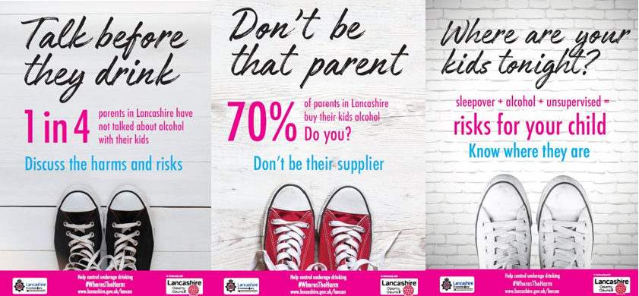
Other initiatives were put in place following public concern or related to particular incidents. In 2021 interventions were put in place in the night-time economy to tackle drug spiking, and prevention frequently takes place in localities based on local intelligence.
Police initiatives delivered by the violence reduction unit include StreetSafe which encourages communities to report signs of drug or alcohol abuse. Following arrests linked to drugs, they have a high profile to deter others and provide confidence to the community. Other prevention work is outlined under the Lancashire Constabulary Serious Organised Crime Strategy. The police follow a 4 P's approach.
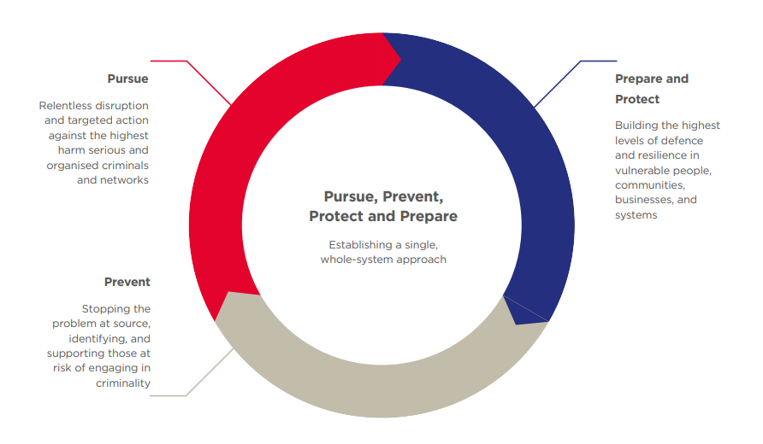

Interventions, support, and signposting are delivered in community settings via family wellbeing services who deliver services from 56 neighbourhood centres across Lancashire. The "team around the family" will refer to drug and alcohol services and provide targeted youth support for teenagers or detachment work in hot spot areas. Where exploitation of children is found (including organised serious gangs, trafficking, or county lines), a multi-agency team including police, social services, or others will work together to reduce the risk and put in place support. Other cases will be referred to safeguarding, and this includes vulnerable adults which could be linked to cuckooing.

We Are With You's work is commissioned by the public health team at Lancashire County Council and work with under 25s on substance misuse. The service includes a family support offer which works with families even if the young person is not engaged with the service. Parents can access 1-1 or group support. Interventions take place in schools including projects such as Mind and Body (self-harm), group work, 121s, or outreach work in the community. This year to date (November 22) the service has delivered group work to 1,460 young people in a range of settings. Within the core offer the service also supports children and young people experiencing "Hidden Harm", including a dedicated child sexual exploitation (CSE) worker, and a cognitive behavioural therapy (CBT) practitioner (from Dec). Drug and alcohol training is provided to schools and health professionals, and delivered monthly free of charge, with 264 professionals attending this training so far this year. Bespoke training is provided to settings on request, e.g., health visitors, children and family wellbeing service (CFWS), prison service, and mental health support teams in school. Attendees are given access to a young person's resource book which helps professionals from any background to start a conversation about drug and alcohol use with young people. This resource also contains a screening tool (DUST - Drug Use Screening Tool).

Preventative projects such as the "Link-Up group" are delivered in partnership with Red Rose Recovery. The programme includes drugs awareness, addiction awareness, harm minimisation, reduction planning, and relapse prevention over a minimum of ten weeks, and other projects including a family and foster carers support group. The services new schools' team will be offering We Are With You's evidence-based 'Risk-It' and 'STAR' programmes (from Q4).

We Are With You do a significant amount of preventative work with young people and in 21/22 referrals were made from a range of sources (figure 10).

Figure 10: Referrals into We Are With You in Q4 21/22
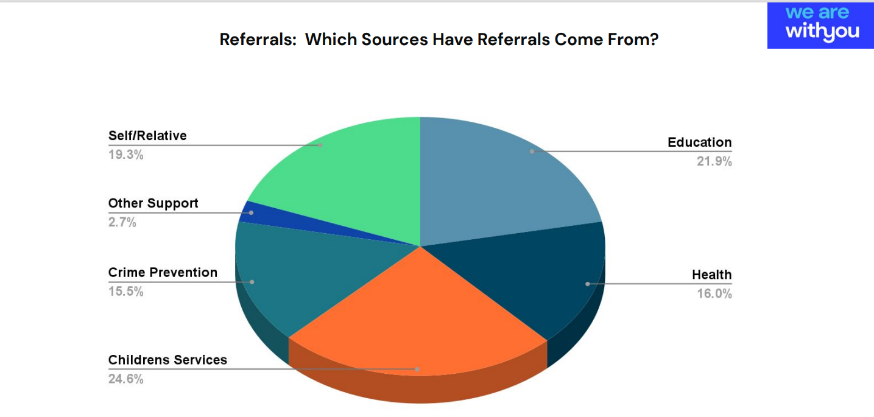

Whilst the prevention work is focused on drugs and alcohol there are wider benefits including reducing the likelihood of crime and antisocial behaviour, and improving wellbeing. Data from the referrals into treatment via We Are With You in Q4 of 21/22, show that 31 young people were engaging in self harm at the start of their intervention, which reduced to 6 at time of exiting the intervention. The number of young people accessing mental health support rose from 20 to 32. There was also a reduction in child exploitation and an increase in children returning to education or employment.

With a whole system approach the children and young people justice service (CYJS) team now routinely ask for advice and information on substance misuse issues. The positive aspects of this multi-agency partnership are that social care and health support approaches are brought together under one support network. This approach has led to reduced risk factors for the clients through having a wrap-around approach within the CYJS multi-disciplinary team.

Some of the prevention work is very focused such as interventions and prevention work in partnership with the probation and criminal justice services and others to ensure pathways are embedded during transition from prison to release and preventive measures are in place for prolific offender who spend small amount of time in prison (under 20 days or less) and do not access treatment within the prison setting, nor do they access treatment services when they are not in prison due to continual cycle of revolving doors. It is recognised that the criminal justice pathway plays a key part in the prevention work, and it is recommended that the pathways and referrals are mapped, and recommendations are made to promote a whole systems approach.

Having safe accommodation is a key element for homeless prison leavers who do not meet the criteria for priority need for accommodation. In Lancashire we have community accommodation service tier 3 (CAS3) which provides temporary accommodation for up to 84 nights for homeless prison leavers and those moving on from approved premises (CAS1) or the bail accommodation and support service (CAS2), and assistance to help them move into settled accommodation.

Some of the prevention work around homelessness and rough sleepers takes place within the district council who have the statutory homeless function. The homeless team provides wider support and signposting such as on welfare, debt advice and employment and opportunities to engage in other peer support activities or connections via treatment or recovery services. A range of preventive work takes place in communities and includes safe and supported accommodation or interventions such as Street Aid in Preston and Lancaster to reduce the amount of street begging. Other interventions at a local include the implementation of Public Spaces Protection Orders, which are aimed to address anti-social behaviour and tackling street drinking.
Wider aspects around prevention include providers, services and charities supporting sex workers and other forms of addiction such as gambling, or trauma support and prevention of drugs and alcohol cannot be seen in isolation. This is the same for co-occurring mental health. It is quite common for people to experience problems with their mental health and alcohol/drug use (co-occurring conditions) at the same time.

Whilst recognising schools are a key setting to achieve a generational shift in demand for drugs, workplaces who support people in recovery also can make a positive impact in prevention to support successful treatment and for people to retain in employment. Actions are needed around addressing the stigma and providing flexible, supportive, and compassionate workplaces like what is seen with mental health support.

Across a range of partnership more prevention work will be taking place e.g., road safety partnership to reduce number of incidents linked to drink driving and being under the influence and the action plan recommends a deeper dive on the prevention work to review any gaps and duplication to shape future prevention work.

Support and signposting

Part of the prevention work is to raise the profile and access to support which can be via a range of areas such as Youth Zone webpage, or Talk Zone services or via charities and commissions via We Are With You for young people.

Adults wanting support with alcohol and substance misuse support is provided via Inspire CGL Inspire-CGL Central/North Lancashire or Inspire East Lancashire and provisions are put in place via other organisations such as The Well Community and Red Rose Recovery which supports using a lived experience recovery community approach The Well Communities and Red Rose Recovery.

Lancashire User Forum (LUF) gives service users and their families or carers a space to talk and share experiences. Service Users work side by side with treatment providers and professionals as LUF. It provides a chance to meet people with similar interests and aspirations and attend talks and workshops and activities. LUF provides a collective voice for the recovery community in Lancashire.

Acknowledgements

With thanks to Chris Lee (Public Health Specialist, Lancashire County Council), Lee Harrington (Senior Public Health Practitioner, Lancashire County Council), Fiona Inston (Emerging Talent Consultant, Lancashire County Council), Lee Sculpher (Senior Partnership Intelligence Analyst, Lancashire Constabulary), Donna Gadsby (Business Intelligence Analyst, Lancashire County Council), Ann Gawne (Public Health Practitioner, Lancashire County Council), and A-Lan Banks (Specialty Registrar in Public Health, Lancashire County Council).

Appendix

Demographics

Lancashire-12 (L-12) is the term for the 12 local authorities in the Lancashire County Council area. It does not include the two unitary authorities of Blackburn with Darwen and Blackpool.

Population data and population projections are useful for understanding the shifts and changes in different groups across the county and local authorities. Deprivation data can also provide insight to show where need may be greatest. This combined intelligence can aid planning, commissioning, and decision making for service provision.

Population

The population in L-12, as captured by the Census 2021, is 1,235,300. The district breakdown below shows the female/male split.

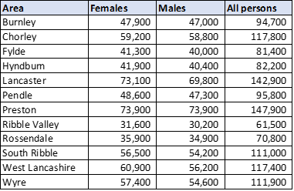
Source: Census 2021
Note: male and female values combined will not match 'all persons' totals due to rounding.

Population projections 2018 to 2043

The most recent population projections from the Office for National Statistics incorporate the period 2018 to 2043 (based on 2018 population data).

Analysis by age shows the number of children aged 0 to 15 will peak in 2022 and then decline.

The working-age population is predicted to peak in 2032 and the older population are predicted to continue to increase, with more in the 85 and over age bracket each year if life expectancy increases over the same period.

- Reflecting the England picture, L-12 sees a projected increase in males and females in the older age brackets: 70+ years.
- The increase is greater for males aged 85+ compared to females.
- While L-12 will see a small increase in females aged 35-39, England sees a decrease.
- For males in L-12, the largest projected decreases are in those aged 45-49 (-5.4%) and 50-54 (-5.3%).
- For females the projected decreases are largest for those aged 45-49 (-7.9%) and 5-9 (-5.7%).
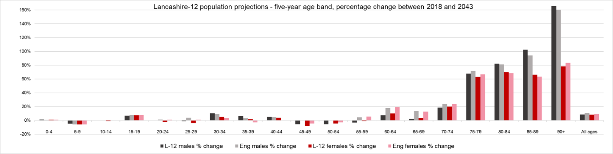
Source: population projections, Office for National Statistics

The charts below show the population projections for each district, broken down by five-year age brackets.

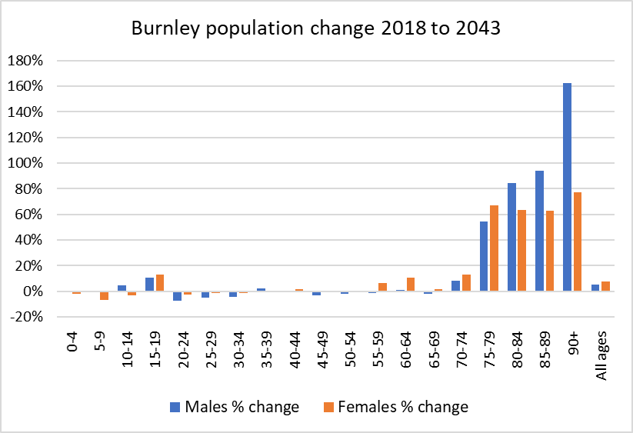 | 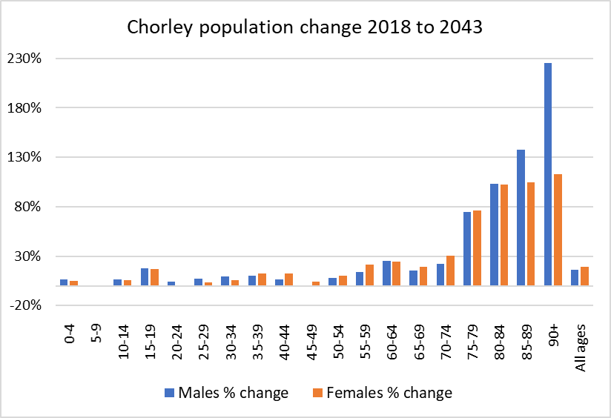
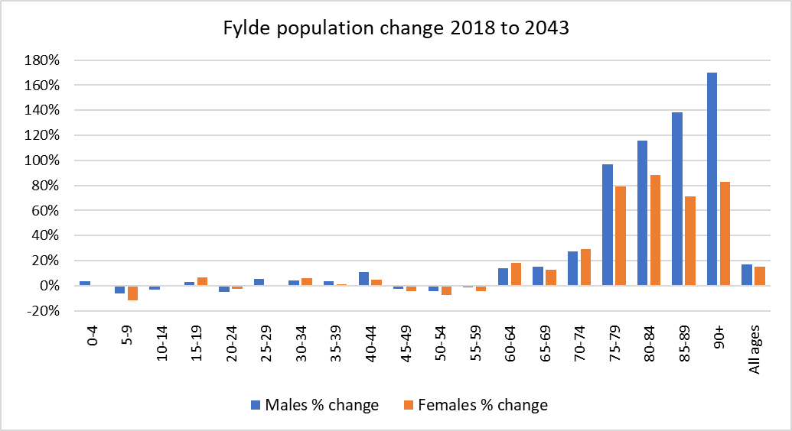 | 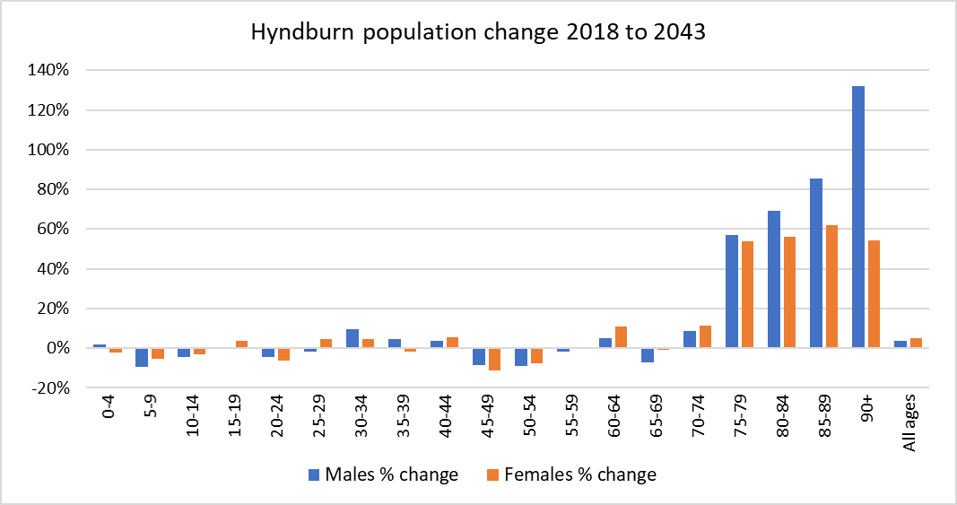
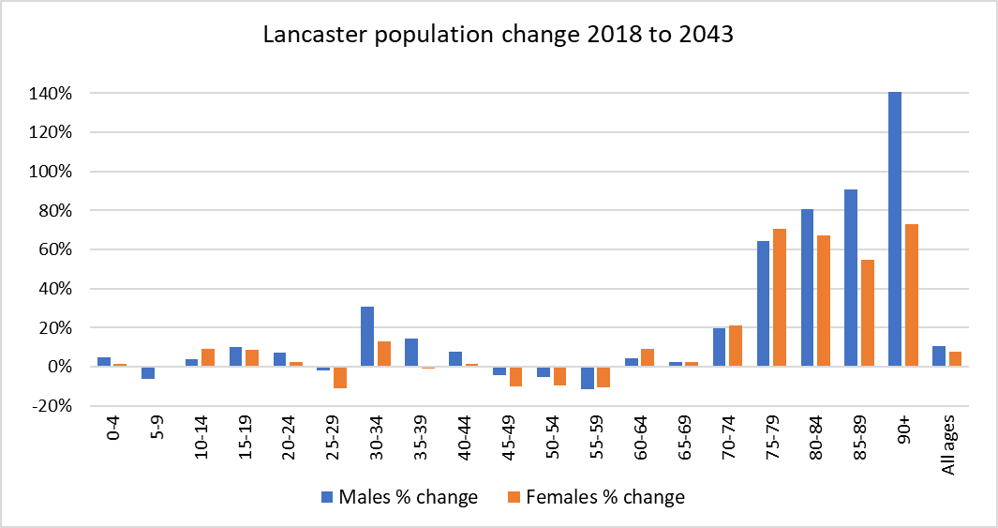 | 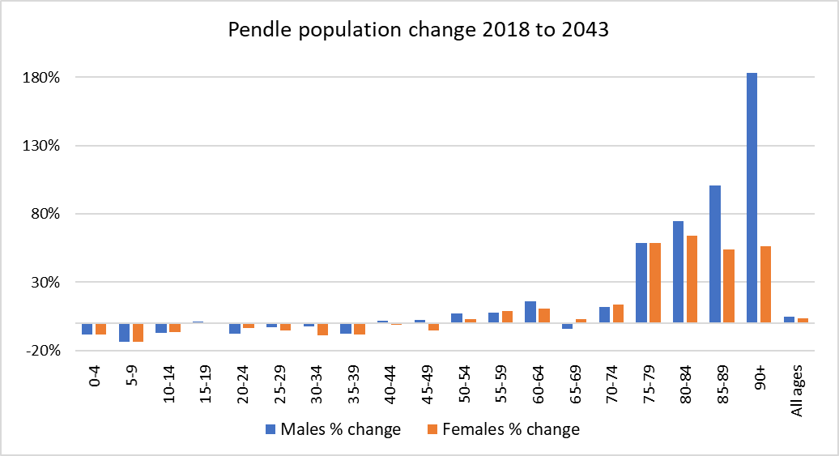
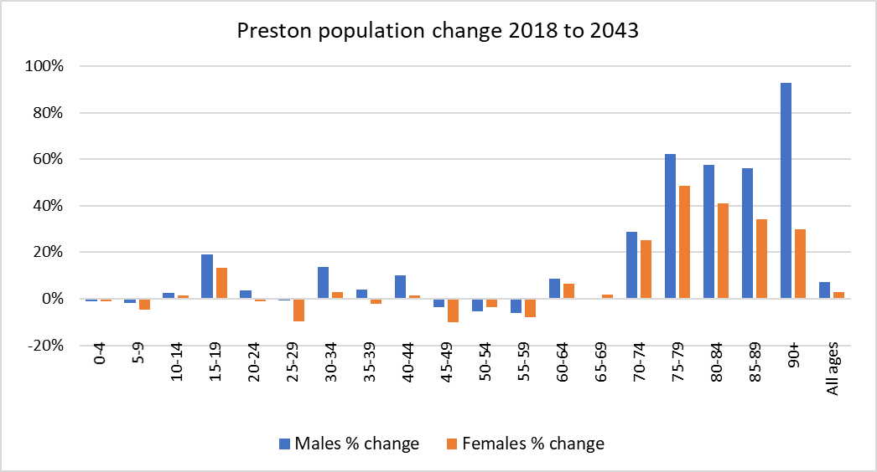 | 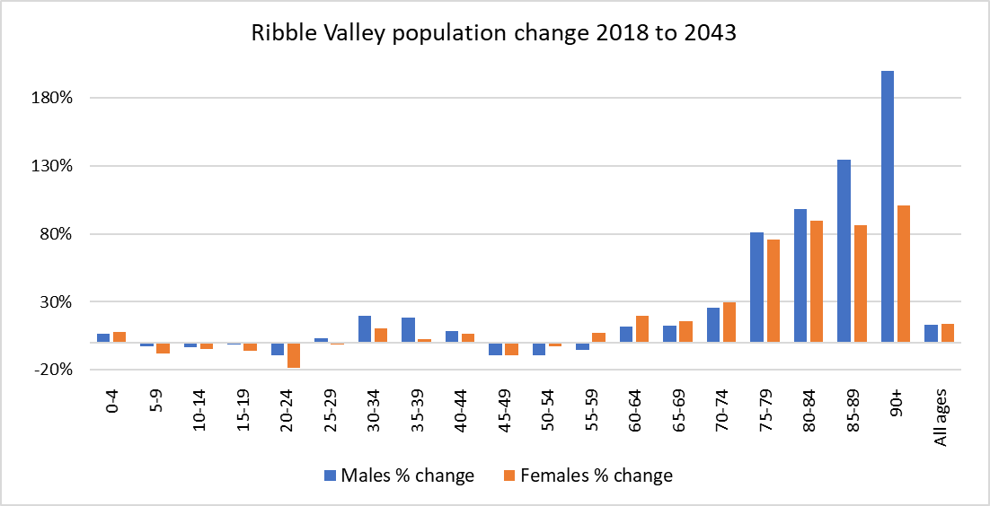
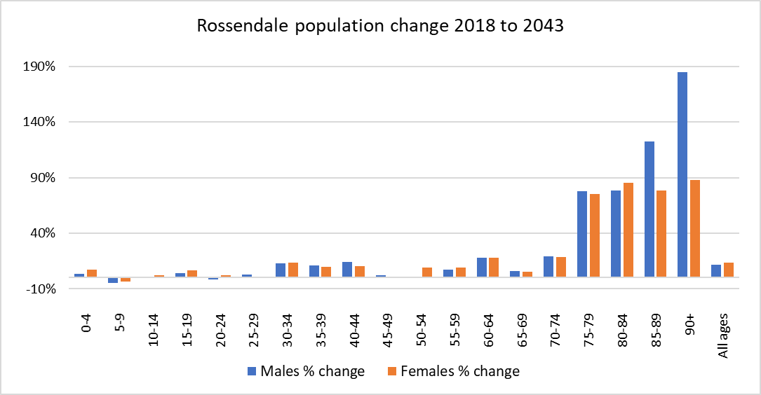 | 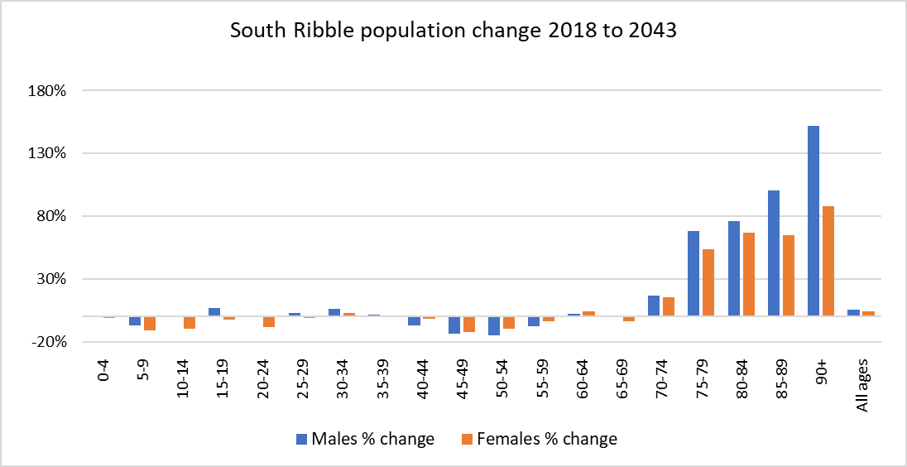
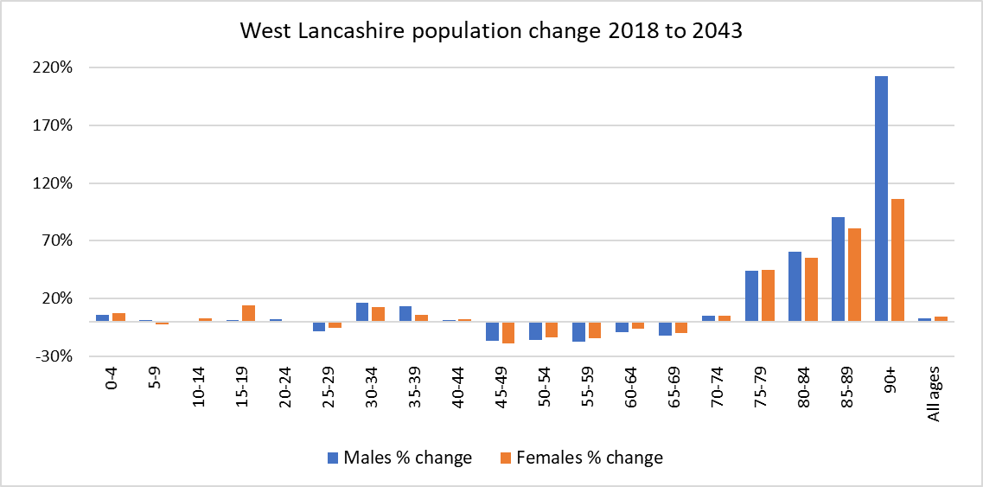 | 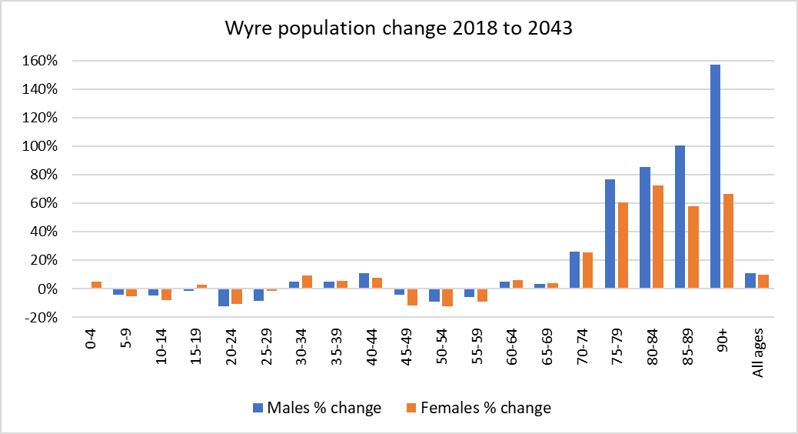
Life expectancy

As noted above, the population projections are dependent on life expectancy for males and females. Life expectancy has fallen across Lancashire and remains significantly worse in most districts for males and females (see charts below).

District life expectancy for males, 2018-20:
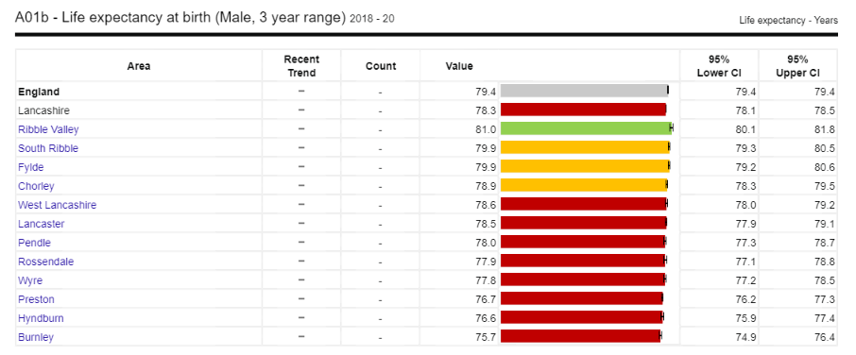
Trends cannot be calculated for male life expectancy.

District life expectancy for females, 2018-20:
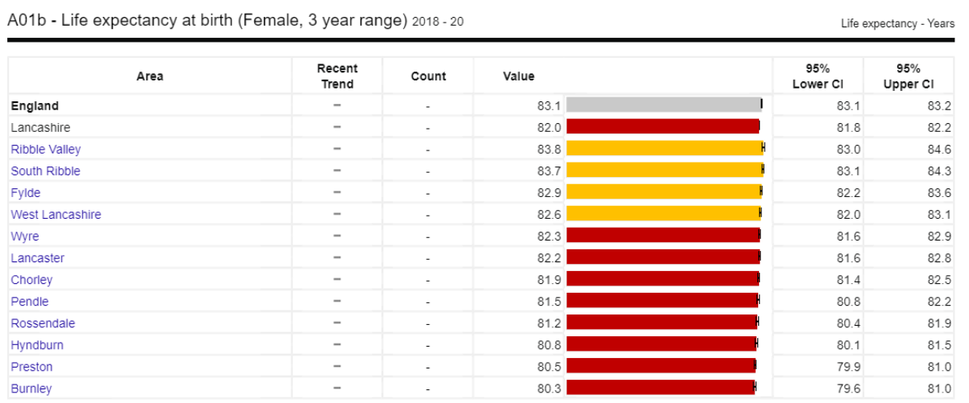
Trends cannot be calculated for female life expectancy.
Source: Office for Health Improvement & Disparities, Public Health Outcomes Framework

Life expectancy for males from 2001-03 to 2018-20, Lancashire
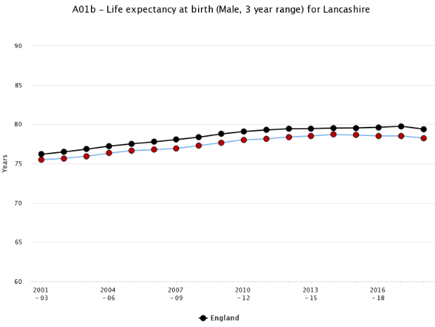

Life expectancy for females from 2001-03 to 2018-20, Lancashire
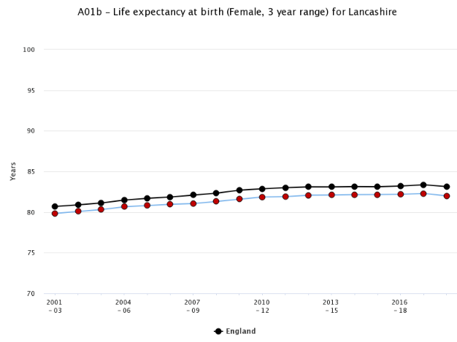
Source: Office for Health Improvement & Disparities, Public Health Outcomes Framework

Deprivation

The table below shows the deprivation breakdown for each district. It identifies what proportion of the population are in each deprivation decile. The deciles are ranked from one to ten, where one is the most deprived decile and ten is the least deprived.
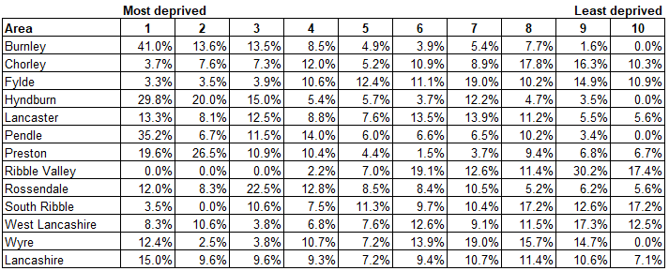
East Lancashire districts (excluding Ribble Valley), along with Preston are the most deprived in the county.
Ribble Valley is the least deprived authority in Lancashire, and one of the least deprived in England.

